

Unattended Regression Test Automation
Rational Functional Tester

Version 0.1

Author | Dave Horne
Document Status | Draft
Document Ref. No.
Document Path Name
Document Version | 0.1
Template version
Date Issued

© The Automobile Association Limited [2015]. All rights reserved. This document and any information contained herein is the property of The Automobile Association Limited. No part may be disclosed, reproduced, stored in a retrieval system, or transmitted in any form or by any means, electronic, mechanical, photocopying, recording or otherwise, without the prior written permission of the copyright owner.
TABLE OF CONTENTS
1 Introduction 4
1.1 Overview 4
1.2 Purpose of Document 4
1.3 Unattended Executions Detail 4
1.3.1 Deciding Execution Commencement Timing 4
1.3.2 Mechanism to Start Test Executions 5
1.3.3 Required Client Side Resources, Dependencies and Tweaks 5
1.3.4 Pre Test Preparation 5
1.3.5 On Test Completion 6

DOCUMENT CONTROL

Version History

Version | Date | Author | Description
0.1 | 13/11/15 |  | First draft version.

Glossary

Term | Meaning

Introduction
  - Overview
Due to the 3 to 4 man hours required and hardware resources needed to execute the existing test automation regression packs (4 client PC’s tied up for 3 to 4 hours), the option of unattended test executions was investigated, and the technical details of which is provided here.
  - Purpose of Document
This document provides the detailed (Client) PC setup to enable selective executions of existing RFT regression test packs. This document does not detail any RFT tool detail outside the context of unattended test executions.

Unattended Executions Detail

Deciding Execution Commencement Timing
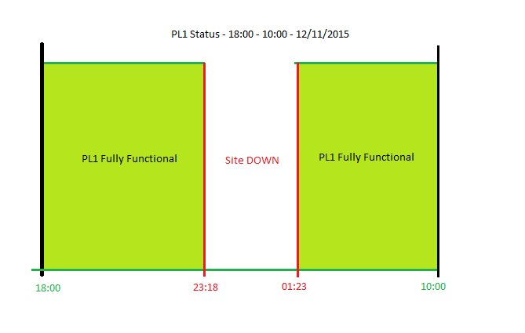
Typical ‘out of hours’ test environment availability
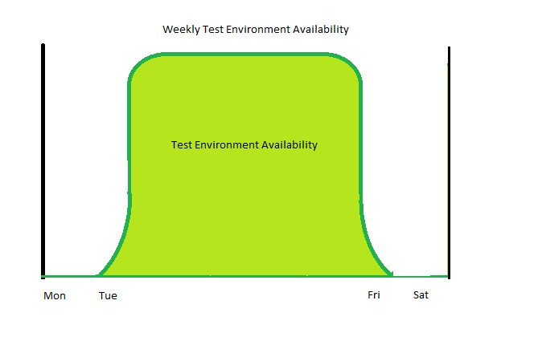

Friday PM until Monday AM, activities server side prevent test executions (Currently).

Mechanism to Start Test Executions
- Scheduled Task
  - Currently the test automation task starts as per the timings of the task scheduled.

  - It is possible to detect the test environment re-start, and fire off the test executions on the back of this event.

- Batch File
  - The batch file ‘Unattended_RFT_Executions.bat’ is the file launched by the task scheduler.

- RFT Task
  - The above batch file starts a headless RFT session, and runs the test ‘Overnight_Regression_Testing’

  - This file in turn, manages the client PC dependencies and specific regression test definitions.

Required Client Side Resources, Dependencies and Tweaks

- Dontsleep ☺
  - Application to prevent hibernation of the client PC. This application allows the client monitor to be OFF during test executions

- UAC Settings
  - User Account Settings, even with Win 8.1, and logging in with local admin rights. Security policies triggers UAC refresh when test executions occur.
  - This causes security dialog confirmations, this therefore needs to be reset back to ‘OFF’ after test execution begins

- Pre-configured scheduled tasks
  - Pre-existing scheduled tasks that clash with the test execution timings need to be temporarily suspended to allow test executions to complete.

- Software updates
  - Automatic software updates needs to be temporarily suspended to allow test executions to complete.

- Other Points
  - The test environment is key, so obviously if an unexpected outage occurs, then the tests will not complete.

  - Similarly, unexpected events client side will also prevent test completion (obvious I know, but stated for clarity).

Pre Test Preparation
- Ensure desktop is clear (not a dependency, but good practice).

- No unnecessary applications or tasks running.

- Good idea to reboot client PC prior to the test execution.

On Test Completion

- Test console output log ‘unattended.txt’ will be generated, and can be found in route C:\ Drive.

- Good practice to rename file with date and time embedded (not currently done programmatically).

- Detailed Test Log Folder is also generated ‘Overnight_Regression_Testing’

- This is an HTML file comprising many test assets, i.e., verification points, baseline and actual data comparisons as well as screen shots of transactions on each journey/scenario completion.

- This file is best viewed through RFT for ease, but each element can be viewed externally via the appropriate application.

- The FOLDER can be found in C:\RFT\AA_DotCom_Logs on the local client PC.

END OF DOCUMENT.

